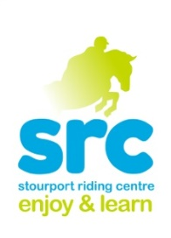 **Stourport Riding Centre**

**October Half Term Children’s Activities**

**Picnic Ride**

**Wednesday 26th October**

**12.30-2.30pm**

This activity is suitable for all abilities, including complete beginners. This involves a gentle stroll through the woods and fields and a pony picnic in the countryside.

(Picnic is weather permitting. We always have a plan B which includes a walk out and lunch in the dry.)

One of our most popular activities so book early to avoid disappointment

£29.00 Packed lunch required

**Own Your Own Pony Day**

**Tuesday 25th October**

**9.30am-3.30pm**

An action packed day of pony fun. Activities include

**Group lesson**

**Yard Activity**

**Picinic ride**

**Clear Round Show-jumping**

**Pony Games**

One of our most popular activities so book early to avoid disappointment

£49.00 Packed lunch required

Suitable for off lead rein riders

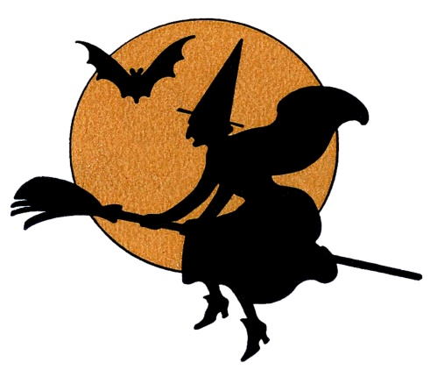

**Pony Club Badges**

**Wednesday 26th October**

**10am-12pm Under 9years**

**1.30pm-3.30pm 9 Years+**

This is an opportunity for our Pony Club members to have their achievements recognised. These sessions will see successful riders awarded badges

Under 9 years will be getting their:

* Pony Behaviour
* Horse Clothing

9 Years+ will be getting their badges in:

* Equine behaviour
* Loading.

£20.00 per session.

**Show Jumping Clinic**

**Monday 24th October**

**10-10.45 Grade 3**

**10.45-11.30 Grade 2**

**11.30-12.15 Grade 1**

**&**

**1.30-2.15 Grade 3**

**2.15-3.00 Grade 2**

**3.00-3.45 Grade 1**

Suitable for our off lead rein riders, A good way to really improve your jumping position , lines and all you need for a Clear Round plus being a great confidence boost. Small groups mean plenty of jumps!

£25.00 for 45 minutes

**Show Jumping Evening**

**Thursday 27th October**

**5pm start.**

**(Grade 1&2 only)**

**Clear Round 50cm**

**Class One 55cm**

**Class Two 60cm**

**Class Three 65cm**

**Clear Round £6.00**

**Class £10.00**

**Junior/Senior Lessons.**

**Thursday 27th October.**

**One adult and One Child.**

**30 minute sessions for £46.00**