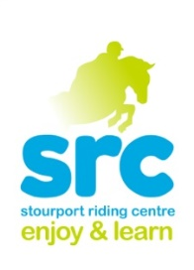 **Stourport Riding Centre**

**October Half Term Children’s Activities**

**Picnic Ride**

**Monday 26**

**Wednesday 28th October**

**12.30-2.30pm**

This activity is suitable for all abilities, including complete beginners. This involves a gentle stroll through the woods and fields and a pony picnic in the countryside.

(Picnic is weather permitting. We always have a plan B which includes a walk out and lunch in the dry.)

One of our most popular activities so book early to avoid disappointment

£29.00 Packed lunch Required

**Own Your Pony Day**

**Monday 26th October**

**10am-4pm**

An action packed day of pony fun. Activities include

**Group lesson**

**Yard Activity**

**Picinic ride**

**Clear Round Show-jumping**

**Pony Games**

One of our most popular activities so book early to avoid disappointment

£49.00 Packed lunch Required

Suitable for off lead rein riders

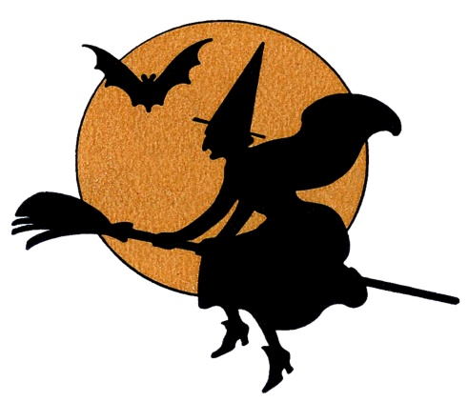

**Show Jumping Clinic**

**Wednesday 28th October**

**10-10.45 Grade 3**

**10.45-11.30 Grade 2**

**11.30-12.15 Grade 1**

Suitable for our off lead rein riders, A good way to really improve your jumping position , lines and all you need for a Clear Round plus being a great confidence boost. Small groups mean plenty of jumps!

£23.00 for 45 minutes

**ABRS Rosette Awards**

**Thursday 29th October**

**10-11am Lead rein riders**

**11-12pm Off Lead rein riders**

This is an opportunity for our riders Grade 3-5 to have their achievements recognised through a series of exciting new awards. These sessions will see successful riders awarded one Equitation and one Stable management award including a **rosette** and **certificate**

£25.00