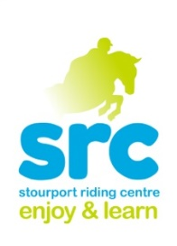**Stourport Riding Centre**

**October Half Term Children’s Activities**

**Own Your Own Pony Day**

**Monday 23rd October**

**Wednesday 25th October**

**9.30am-3.30pm**

An action packed day of pony fun. Activities include

**Group lesson**

**Yard Activity**

**Picinic ride**

**Clear Round Show-jumping**

**Pony Games**

One of our most popular activities so book early to avoid disappointment

£49.00 Packed lunch required

Suitable for off lead rein riders

**Countryside Ride**

**Thursday 26th October**

**3.00- 4.00pm**

A chance to get out and explore the countryside on horseback with an escorted hack through the woods.

Limited spaces on this popular activity!

Strictly Grades 1 & 2 only £25.00

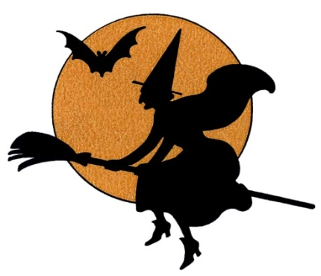

**Mini Own Your Own Pony Day**

**Thursday 26th October**

**10.00 am- 2.30pm**

A slightly shorter version of the Own a Pony Day aimed at our younger riders who want to spend the day with their favourite ponies. Activities include a lesson, grooming, picnic ride, Show jumping and pony games- lots of riding, lots of fun!

£40.00 per rider

**Show Jumping Clinic**

**Wednesday 25th October**

**9.30-10.15 Grade 3**

**10.15-11.00 Grade 2**

**11.00-11.45 Grade 1**

**1.15-2.00 Grade 3**

**2.00-2.45 Grade 2/1**

Suitable for our off lead rein riders, A good way to really improve your jumping position , lines and all you need for a Clear Round plus being a great confidence boost. Small groups mean plenty of jumps!

£25.00 for 45 minutes

**Show Jumping Evening**

**Thursday 26th October**

**5pm start.**

**(Grade 1&2 only)**

**Clear Round 50cm**

**Class One 55cm**

**Class Two 60cm**

**Class Three 65cm**

**Clear Round £6.00 Class £10.00**

**Private and**

**Semi Private Lessons.**

**Tuesday 24th October.**

**30 minute sessions for**

**£30.00**