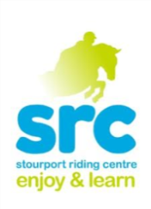
Christmas 2017
Santa is coming to the…

Decorate the ponies, watch the helpers display ride, take part in the Christmas themed pony games and there is even a visit from Santa in his sleigh with a present for every rider! Most suitable for riders Grade 3, 4 and 5
Thursday 21st December 10am- 12pm or 1pm – 3pm £26.00
Christmas Own Your Own Pony Day

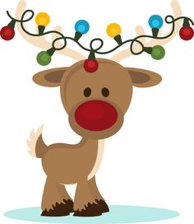
So Santa might not be able to fit a pony down the chimney this Christmas, but maybe a whole day with your favourite one of ours might do? An action packed day of riding, festive activities and… more riding! Suitable for off lead rein riders Grades 3 and 4 Packed Lunch required
Wednesday 20th December 9.00 am- 3.00pm £49.00
Seniors Christmas Party

A fun filled evening of Show jumping and Pony Games in the International Arena. A chance for our more experienced riders to have some festive fun!
Grade 1 and 2 riders only but spectators very welcome!
Thursday 21st December 4.00pm- 6.00pm
£26.00
Book now to avoid disappointment!
Please note bookings can only made with a £10 deposit. Please book at Reception or over the phone. We cannot accept email bookings.

